10/28/2019

Milestone 3

Process Modelling



Aidan Campbell Beryon Clark Harley Lenton Justin Alho Evan Guest

ITI Solutions

Client Contact: Rachel Frantz

**Client Signature:** _________________________________________   **Date:** ____________

Edenbridge Family Services

Scheduling and Time-Tracking Database

Software: Schedule ED

Table of Contents

Current Process 1

Current Level 0 Process 1

Current Level 1 Processes 2

Process 1 – New Client Input 2

Process 1 Use Case 3

Process 2 – Schedule Workers 4

Process 2 Use Case 5

Process 3 – Timesheet Input 6

Process 3 Use Cases 7

CRUD Chart (Create, Read, Update, Delete) 8

Proposed System Processes 9

Context Diagram 10

Proposed Level 0 Process 11

Proposed Level 1 Processes 12

Process 1 – Account Creation 12

Process 1 Use Case 13

Process 2 – Shift Management 14

Process 2 Use Case 15

Process 3 – Time Tracking 16

Process 3 Use Case 17

Process 4 – Financial Processing 18

Process 4 Use Case 19

Process 5 – New Client Input 20

Process 5 Use Case 21

Process 6 – User Login 22

Process 6 Use Case 23

Lessons Learned 24

# Current Process

The system that has been requested for us to replace at Edenbridge is a mixture of paper forms and Microsoft Excel spreadsheets. In short, this system contains some mass inefficiencies that drastically lower the potential productivity at Edenbridge. Below is the general overview of the processes of the system that we will be replacing.

## Current Level 0 Process

The level zero diagram provides a look at the way the data flows in the current system.

**Level 0 Current System Diagram**

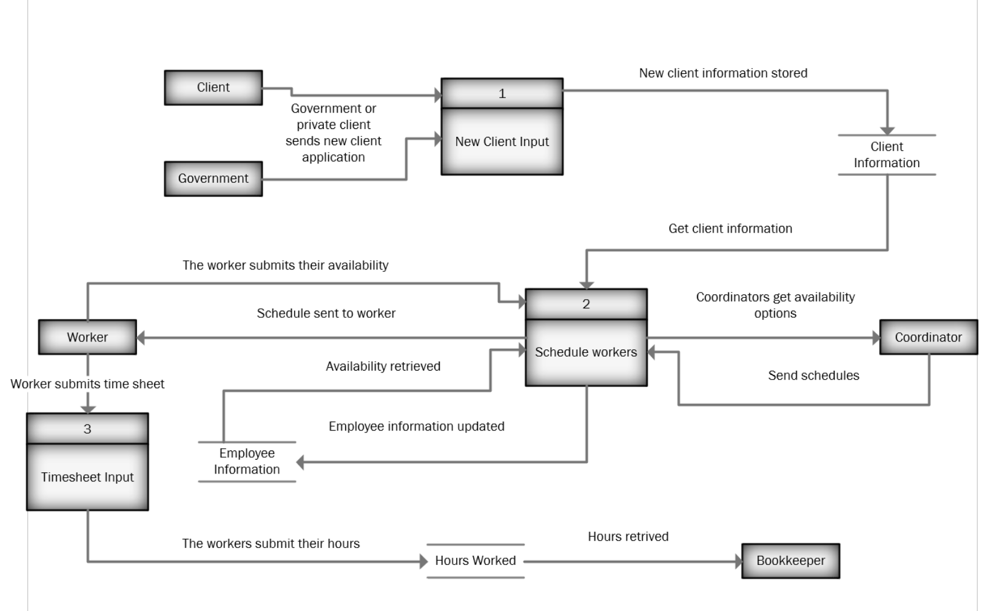

## Current Level 1 Processes

### Process 1 – New Client Input

The current first process involves the addition of new clients, either private or sponsored by the government. When Edenbridge receives a request, the office administrator validates the form to ensure all required information is present, and then stores it. The result is the information required to serve the client is stored and made available for later processes.

**Level 1 New Client Input Diagram**

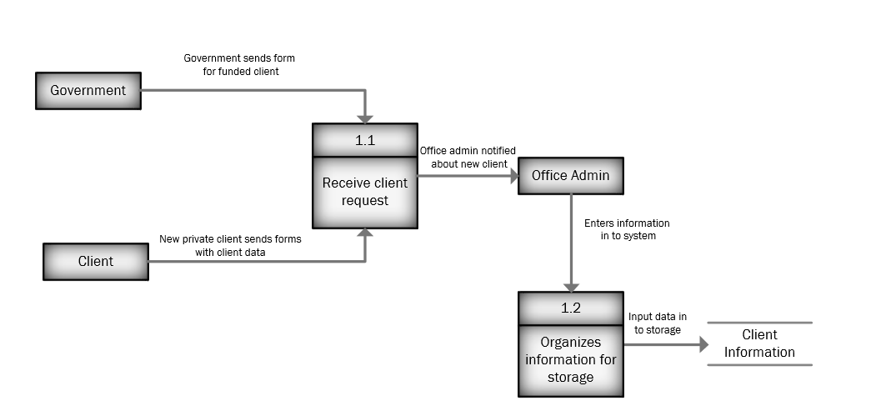

### Process 1 Use Case

|  |
| --- |
| **Use Case:**  New Client Input |
| **Actor:**  System Admin |
| **Description:**  Adding a new client to the system so they can be booked |
| **Trigger:**  A new client needs their data added to the system |
| **Type:**  External |
| **Preconditions:**   * There is room for more clients in the system |
| **Normal Course:**  1: Office administrator is notified about new client from government or private individual  2: Office administrator records new client information and adds it to the system  3: Office administrator informs coordinators about new client |
| **Post Conditions:**   * New client is added to the system to be scheduled |

### Process 2 – Schedule Workers

Coordinators currently go through binders containing client and employee information in order to match employees to shifts. The result of this process is that the coordinator will then contact the worker that is to work the shift, informing them when they will work.

**Level 1 Schedule Workers Diagram**

### Process 2 Use Case

|  |
| --- |
| **Use Case:**  Schedule Workers |
| **Actor:**  Coordinator |
| **Description:**  Coordinators schedule the workers to meet with clients |
| **Trigger:**  Workers’ schedules are for previous pay periods, need new schedules |
| **Type:**  Temporal |
| **Pre-conditions:**   * Coordinator have binders of employee and client information |
| **Normal Course:**  1: Coordinator determines what clients need workers  2: Coordinator finds a suitable worker for the client  3: Coordinator compares schedule with other coordinators to ensure there are no conflicts  3: Coordinator schedules worker for the client  4: Coordinator informs worker about their schedule |
| **Post-conditions:**   * Workers know their schedule * Coordinators’ calendars are updated |

### Process 3 – Timesheet Input

Currently, the third process involves the input and processing of timesheets. Timesheets are input by the workers, which are then sent to the bookkeeper. From there, the bookkeeper enters the data into timesheets and stores it for future use.

**Level 1 Timesheet Input Diagram**

### Process 3 Use Cases

|  |
| --- |
| **Use Case:**  Timesheet Input |
| **Actor:**  Worker |
| **Description:**  Workers report the hours they worked in a two-week period |
| **Trigger:**  Workers have worked for two weeks and need to submit their hours |
| **Type:**  Temporal |
| **Pre-conditions:**   * Worker has a filled-out timesheet * Worker has signed their timesheet |
| **Normal Course:**  1: Worker submits signed timesheet  2: Bookkeeper ensures hours worked are valid  3: Bookkeeper enters the timesheet information in a spreadsheet |
| **Post-conditions:**   * Workers’ hours are submitted |

## CRUD Chart (Create, Read, Update, Delete)

|  |  |  |  |
| --- | --- | --- | --- |
|  | New Client Input | Schedule Workers | Timesheet Input |
| Client | C |  |  |
| Worker |  | CRU | CU |
| Office Admin | CRUD |  |  |
| Bookkeeper |  |  | UR |
| Coordinator |  | CRUD | R |

# 

# Proposed System Processes

The system we are proposing will make many aspects of the current workflow at Edenbridge far simpler and much more efficient. Through the course of this, we hope to ensure that every aspect about this system will be an improvement over what is currently implemented there. In addition, this system will centralize many of the processes, allowing a greater degree of control over data flowing into and out of the system. The following data-flow diagrams (DFDs) will detail the processes included in our proposed system.

The system we are proposing will at a glance be able to:

* Provide workers an easier way to submit their hours
* Allow coordinators to create schedules for workers
* Give financial bookkeepers a more convenient way to export required data to carry out accounting processes

The system will be tailored for the specific circumstances of Edenbridge, meaning the front-end of the system will take on the form of a website. In addition to basic services already outlined, the system will perform the following to facilitate what is needed:

* Allow users to log in and access various resources
* Provide a shift management service for coordinators
* Provide a service that facilitates the distribution of financial data to bookkeepers
* Allow for the creation and management of accounts

## Context Diagram

This context diagram gives a broad look at the different users interacting with the system, as well as their interactions with the system:

**Context Diagram**

## Proposed Level 0 Process

The level zero diagram serves as an overview into the entire system as proposed. Subprocesses will be detailed after this diagram.

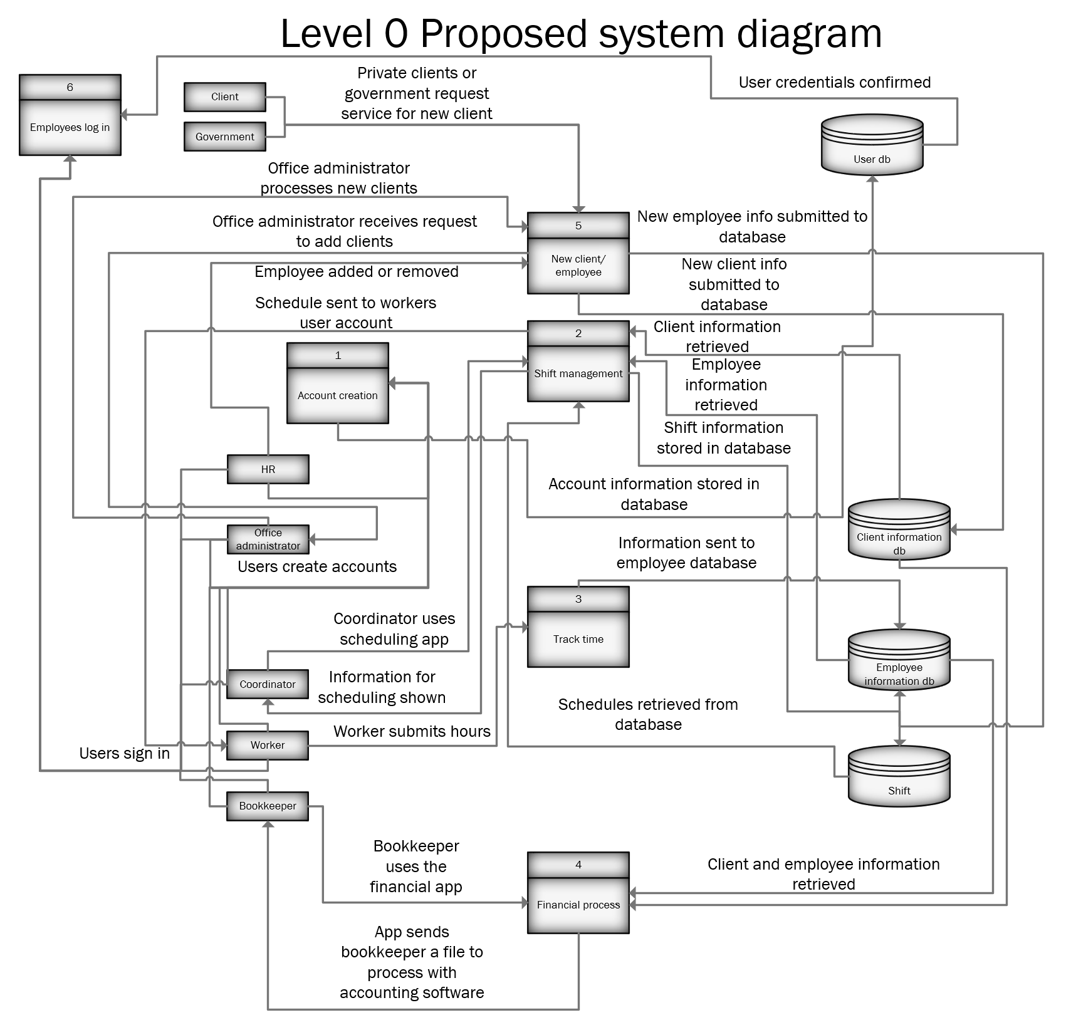

## Proposed Level 1 Processes

### Process 1 – Account Creation

Process 1 covers the creation of accounts. The system administrator will be the primary creator for any accounts. Any forms that are sent in will have inputs be sanitized to prevent any instances of tampering. At the end of it, the finalized data will be added to a database dedicated to user information.

**Level 1 Account Creation Diagram**

### Process 1 Use Case

|  |
| --- |
| **Use Case:**  Employee Account Creation |
| **Actor:**  System admin |
| **Description:**  Allows new workers to be added to the database so they can be scheduled |
| **Trigger:**  New employee is hired and needs an account |
| **Type:**  External |
| **Pre-conditions:**   * System admin is authenticated * User database is online * Web server is online |
| **Normal Course:**  1: System admin adds new worker to system  2: System then formats the data  3: System add new worker to the data base |
| **Post-conditions:**   * New worker is added to the database * System admin is added |

### Process 2 – Shift Management

Process 2 involves coordinators acquiring information related to clients and employees, with the end goal being creating shifts based on availabilities and capabilities of employees. The system will display to the coordinator all required information in order to be able to make an informed decision for any given client. Once this is done, a shift will be created, and an associated notification is sent to the employee matched up with the information they require to work the shift.

**Level 1 Shift Management Diagram**

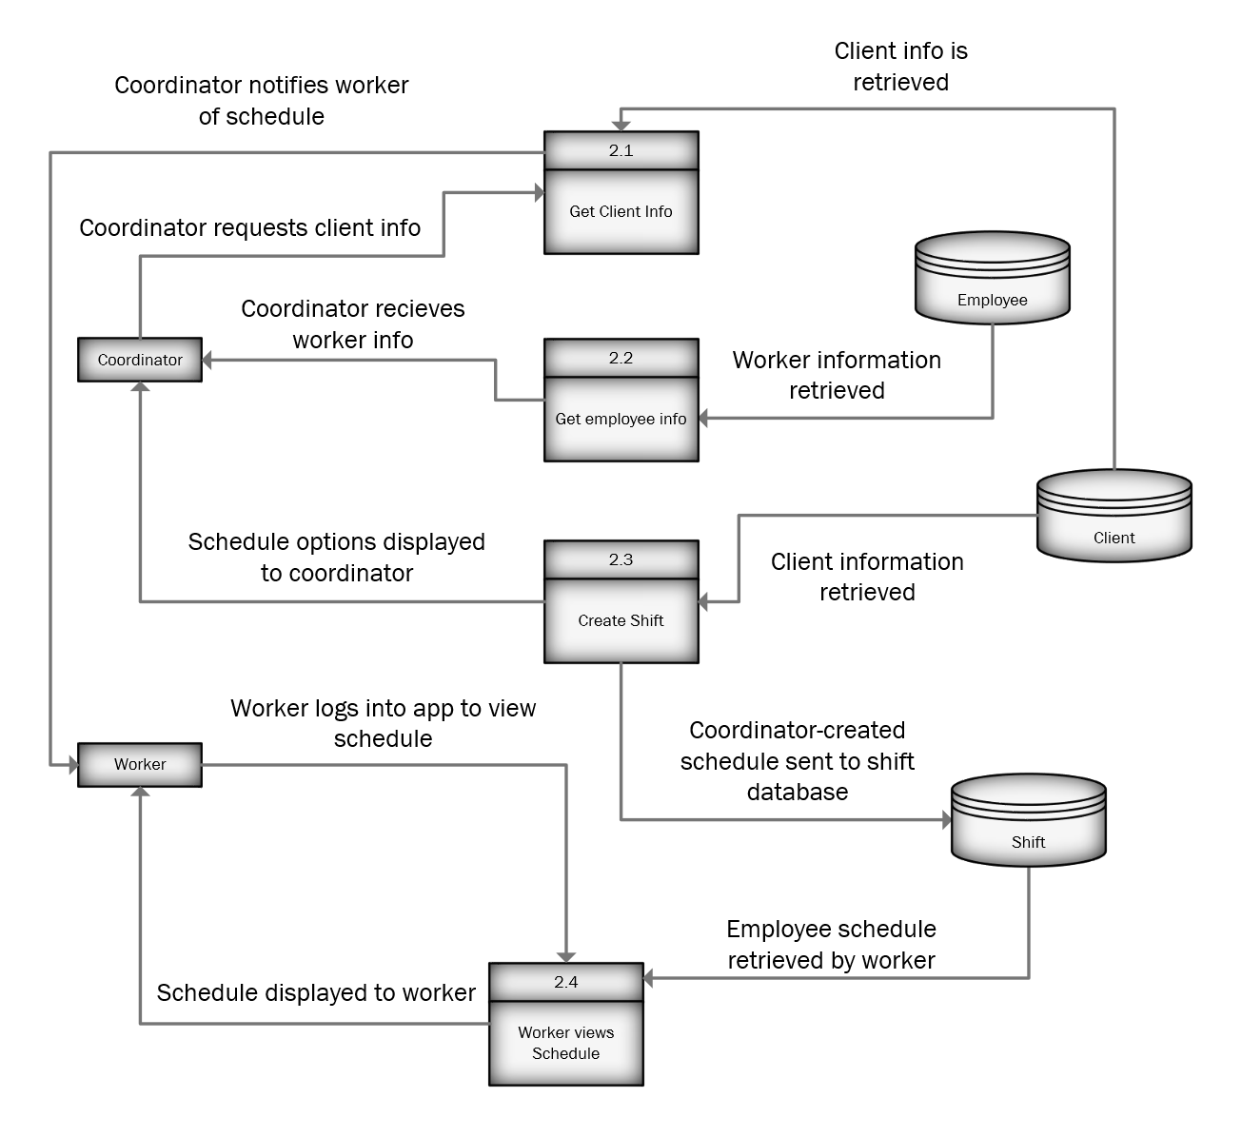

### Process 2 Use Case

|  |
| --- |
| **Use Case:**  Shift management |
| **Actor:**  Coordinator |
| **Description:**  Coordinators schedule the workers to meet with clients |
| **Trigger:**  Workers’ schedules are for previous pay periods, need new schedules |
| **Type:**  Temporal |
| **Pre-conditions:**   * Coordinator has been authenticated * Worker database is online * Client database is online |
| **Normal Course:**  1: Coordinator schedules workers for a two-week period  2: Coordinator chooses if they want to make changes to the workers schedule  3: System puts the booked hours in to schedule database |
| **Post-conditions:**   * Hours are stored in the database * Workers have red flags on their account if they are working overtime or if they need a break from work * The worker that is selected will have the required training to work with that client |
| **Exceptions:**  1E: Coordinator tries to schedule workers overtime; system gives red flag (occurs at step 1)  1: System asks coordinator if they want to proceed anyways  2a: Coordinator schedules employee anyways, continues to step 2  2b: Coordinator cancels booking, starts over from step 1 |

### Process 3 – Time Tracking

Process 3 is relatively simple, with the only major step being an employee submitting a form containing their hours. This data is formatted and then submitted to a database containing a compilation of those hours.

**Level 1 Time Tracking Diagram**

### Process 3 Use Case

|  |
| --- |
| **Use Case:**  Time Tracking |
| **Actor:**  Worker |
| **Description:**  Workers report the hours they worked in a two-week period |
| **Trigger:**  Workers have worked for two weeks and need to submit their hours |
| **Type:**  Temporal |
| **Pre-conditions:**   * Worker is authenticated * Web server is online * Worker database is online * Authentication database online |
| **Normal Course:**  1: Worker submits hours worked  2: System formats from  3: System puts the formatted hours into the database |
| **Post-conditions:**   * Workers’ hours are submitted |

### Process 4 – Financial Processing

Process 4 revolves around the steps to request and distribute financial information. The base process involves the requesting of required information and validating it before providing a file that can be downloaded and/or exported.

**Level 1 Financial Processing Diagram**

### Process 4 Use Case

|  |
| --- |
| **Use Case:**  Financial Process |
| **Actor:**  Bookkeeper |
| **Description:**  The employees enter their hours worked into the database. The bookkeeper will then convert the data into an Excel file that can then be imported into the accounting software for payroll |
| **Trigger:**  Employees have submitted their hours and they need to be paid |
| **Type:**  Temporal |
| **Preconditions:**   * Bookkeeper is authenticated * Web server is online * Employee information database is online * Authentication database online |
| **Normal Course:**  1: The bookkeeper downloads the past two weeks of hours worked in an Excel file  2: The Excel file is made available for download |
| **Post-conditions:**   * The bookkeepers have the information necessary for accounting |

### Process 5 – New Client Input

Process 5 involves the creation of new clients. In this process, either the government or a private client will submit a request to Edenbridge with all required information. From there, the information is validated and added into the client information database.

**Level 1 New Client Input Diagram**

### Process 5 Use Case

|  |
| --- |
| **Use Case:**  New Client Input |
| **Actor:**  System Admin |
| **Description:**  Adding a new client to the system so they can be booked |
| **Trigger:**  A new client needs their data added to the database |
| **Type:**  External |
| **Preconditions:**   * System Admin is authenticated * Client database is online * User authentication database is online * Web server is online |
| **Normal Course:**  1: Office administrator is notified about new client from government or private individual  2: Office administrator enters client information into the system  3: system formats data and sends it to the client database |
| **Post Conditions:**   * New client is added to the database |

### Process 6 – User Login

Process 6 encompasses the login process. Much of this is self-explanatory, should a user request to access more secure sections of the interface of the system, they will be required to log in and have the appropriate access credentials to gain access to the requested information or sections.

**Level 1 Employee Login Diagram**

### Process 6 Use Case

|  |
| --- |
| **Use Case:**  Employee Login |
| **Actor:**  Employee |
| **Description:**  Employee logs in to the system to access restricted content |
| **Trigger:**  An employee clicks an option to log in to the system |
| **Type:**  External |
| **Preconditions:**   * User authentication database is online * Web server is online |
| **Normal Course:**  1: Employee selects the option to log in  2: Employee enters their credentials  3: Entered credentials are compared with credentials in user authentication database  4: Employee with valid credentials is granted access and logged in |
| **Post Conditions:**   * Employee is authorized to view restricted content |
| **Exceptions:**  1E: Submitted credentials are not valid (occurs at step 3)  1: System gives an error message, prompts for reentry  2a: Employee enters new credentials, returns to step 3  2b: Employee stops attempting to log in, attempt ends unsuccessfully |

# Lessons Learned

|  |  |  |  |  |  |  |
| --- | --- | --- | --- | --- | --- | --- |
| Date | Submitted By | Milestone | Experience | Lesson | Lesson Type | Effect |
| Oct. 26, 2019 | Beryon | Milestone 3 | This may be similar to an earlier one I did but found out the designer aspects within the Office Suite is a fair deal more powerful than I initially expected, even with 5+ years of experience using it for educational things. | Design and layout aspects within Microsoft Office Suite has far more functionality than it initially looks like. | Technical | With this Milestone as can be observed, there’s a good deal more effort that I put into the presentation of the document and the layout such as with the table of contents which is almost automated with using the styles bar on the home tab. This knowledge will be carried forwards into not just other documents, but all files created during this project. |
| Oct. 26, 2019 | Evan | Milestone 3 | Visio’s sharing policies are not as optimized as the rest of the office suite. At multiple times what was the newest version was unclear. | Don’t rely on Microsoft office to share and maintain files across users. | Personal | If Visio or a program similar is used in the future, a repository type program needs to be used. |
| Oct. 24, 2019 | Aidan | Milestone 3 | Not knowing enough about the scheduling process and how it is going to function | Focusing too much on the extra details of the system and not asking questions about some essential parts of the scheduling system | Academic | I will try to look at the big picture more often to check if I am only looking at one part |
| Oct. 24,  2019 | Harley | Milestone 3 | Received a poor grade on Milestone 2 | Proofreading everything extensively is very important to ensure the documentation is up to the standard expected of us. | Academic | I will now be aiding in the proofreading and revision going over the deliverables multiple times to ensure what we produce is high quality as much as I’m able to. |
| Oct. 18, 2019 | Beryon | Milestone 3 | Lesson? Reminder? Whichever, finally sunk in that this is an actual system being developed. | Far more detail than what I was accustomed to doing with classwork is required for this systems project. | Personal | Going forwards, will be redoubling efforts to ensure every little detail with what we do to ensure that it not only fulfills the deliverable requirements, but also to whatever specification the client provides on an aspect. |
| Oct. 17, 2019 | Justin | Milestone 3 | We started focusing too heavily on aspects of the project that were not very important | Focus on important things first, then think about extras later | Academic | From now on, we will focus on the functionality of the system, anything extra will only be considered after the basic requirements are met |
| Oct. 11, 2019 | Beryon | Milestone 2 | Project has a substantial feature-set, most of which was previously unknown from the first couple times. | Learned a good amount about how to work Project, including different ways to set up tasks and organize them. | Technical | Going forwards, should be far easier to arrange events and plan things out via Project. As a side effect, there’s a measure of knowledge attained in how to potentially display events in the system being developed. |
| Oct. 11, 2019 | Justin | Milestone 2 | Milestone presentation was not great, no intro or conclusion | Make sure assignments include all components | Academic | We will have a team member observe presentations from the other class to know what needs to be included for future presentations |
| Oct 11,  2019 | Harley | Milestone 2 | Organization  of presentation  was not ideal. | The order in which the information is presented is very important if we want it to be easy to follow. | Academic. | Someone will be assigned the duty of analyzing the presentation to ensure the flow of information makes more sense. |
| Oct 11,  2019 | Aidan | Milestone 2 | My work school balance was not great for the first month of school | I learned how far I can push myself before my school begins to suffer from it | Personal | Going forward I am not taking as much hours at work and am going to say no to more hours when asked so I can focus on this project |